Julian Herndon

November 24, 2020

Foundations of Programing: Python

Assignment 06

<https://github.com/Raphidophyte/IntroToProg-Python-Mod06.git>

Python “ToDoList.py” (again)

Introduction:

Clearly the most challenging thus far, Assignment 06 takes the script from Assignment 05 and add some complexity in the form of defined functions that are called in the Main body of the script to perform the processing and I/O work. This script is intended to create a more functional “ToDo List” with a set of tasks and an assigned priority. A starter script was provided by Mr. Root to provide a framework. This Python script first loads data from a .txt file to memory and then presents the user with a five-point menu to choose an action from, including showing what is in the .txt file already, entering new tasks, the ability to delete an existing task and finally saving and exiting. This script was written using PyCharm.

Asignment06 questions and answers:

1. What is a function?

Answer: A function is a tool that allows you to group statements together. Once the function is defined, it can be “called” later to execute the statements in the function.

1. What are parameters?

Answer: Parameters are an optional component of functions. Parameters allow values to “pass” values into the function to be processed. Once a value has been passed into the parameter it is called an argument.

1. What are arguments?

Answer: Arguments are values that have been passed into parameters.

1. What is the difference between parameters and arguments?

Answer: The parameters allow the values to pass into a function for processing whereas the processed values are the arguments.

1. What are return values?

Answer: Not sure! I believe that a return value is simply a value that was returned from a function, that is, the result or the output of whatever the function was doing with the data that was entered. Data is entered, processed by the function and can then be “captured in a variable” or simply displayed immediately.

1. What is the difference between a global and a local variable?

Answer: Local variables are declared and contained within a function and are thus available and able to be “seen” only to the function. Global variables are in the main body of the script and as such are available to the larger (Main) body of the script. A variable inside a function can also be designated as global (for use outside the function) by use of the word “global” before the variable. Shadowing is when a global variable (from outside the function) is used inside a function without being explicitly defined inside function.

1. How do you use functions to organize your code?

Answer: Tasks that have a specific, limited or definable scope or goal that could stand on their own, can be grouped into functions. This allows for easier troubleshooting and separations of sections or objectives inside the script. This also allows the programmer to re-use the same script later in the code by calling the function or to copy and paste the function into a different script, saving time.

1. What is the difference between a function and a class?

Answer: A function is a group of statements. A class is a group of functions.

1. How do functions help you program using the “Separations of Concerns" pattern?

Answer: Separation of Concerns can be greatly improved by using a function to bundle a set of statements, variables and actions. Basically, making a small, sealed up section or module that can be easily separated from the rest of the code if there are problems with the function and also enhances the ability to troubleshoot a specific, stand-alone section of code.

1. How are the debugging tools used in PyCharm?

Answer: The debugging tools can be called up from the run menu in PyCharm. This tool allows the user to run the script one line at a time and test for problems. There is even a separate tab in PyCharm that the debugging will run in to test the script. The programmer can move back and forth between the debugger tab and console tab. By using a break point (left click in margin), an indicator that pauses the code a specific location to work on troubleshooting the script. There is a variable window and tools that allow the user to step over a function, step into code, step out of code, etc.

1. What is a GitHub webpage?

Answer: It is a webpage where you can post and share script and other information/content with other users.

Making the script:

When reviewing the module material and completing the labs, the concepts in the video and purpose and functionality of the labs make sense. However, once I try to apply the concepts and tools independently, I am at a loss and going back to look over the video seem to not be all that helpful. I believe this indicates that I don’t really understand the concepts or have a clear idea of the syntax to make the script run correctly.

For this script, a large portion of my confusion revolved around not initially understanding the separation of the processing, IO and main body sections laid out in the script starter provided by Mr. Root. Specifically understanding the difference between the function in the process class how those were inherently different from the functions in the I/O section (class). The most challenging aspect was clearly separating and delimiting the variable inside the functions from those of a global nature. That is, I initially used some of the nomenclature for the global variable inside the functions, but was not consistent, resulting in nor-operational script. After a discussion after the Mod07 Zoom class and looking over the Assignment06_Answer.pdf, it became painfully clear that a large part of my troubles was rising directly from the inconsistencies around what the variables were being called throughout the script. I systematically went through my script and the answer to ensure consistency. A repeating issue with a “key” for Priority was a result of this lack of consistency.

In the “Input new task and priority” function, I had included additional commands to open the file and save the data to the file, instead of just accepting new task/priorit as the sole purpose of this function. In addition, this not a full separation of concerns, I think the extra code closed the file and thus made it unavailable for the rest of the menu options to function correctly.

Another error I found was in Main body, in the section to remove existing an existing task where I used “.write” instead of “.remove”.

After running through and matching my code to the code in the .pdf, everything suddenly magically worked! I believe I understand the reasons that made my code not work, but I am not certain I understand all of the items that do work well.

Unfortunately, while the script runs well in PyCharm (Figure 1), it does not run well in the CMD prompt (Figure 2). The script will open in the CMD prompt, but is unable to locate and open the ToDoFile.txt document to load the data, so the script stops before it can load the menu and proceed. I was unable to determine why. The path seems correct and the file exists and has data in it. This same error occurred for Assignment05. I will need to follow up with Mr. Root on what I am doing wrong here. Surprisingly, the script will run in the Windows shell (Figure 3) when I right click on the python file to run it. Something is definitely not right with the file path.

As in previous assignments, the script was developed through the now usual iterative process using the Assignemnt06.pdf (Root undated), the Mod6PythonProgrammingNotes (Root undated) and Mod06 Course Video (Root 2019) as primary guides and critically the Assignment6_Answer -1.pdf and Starting Assignment 06 Video.

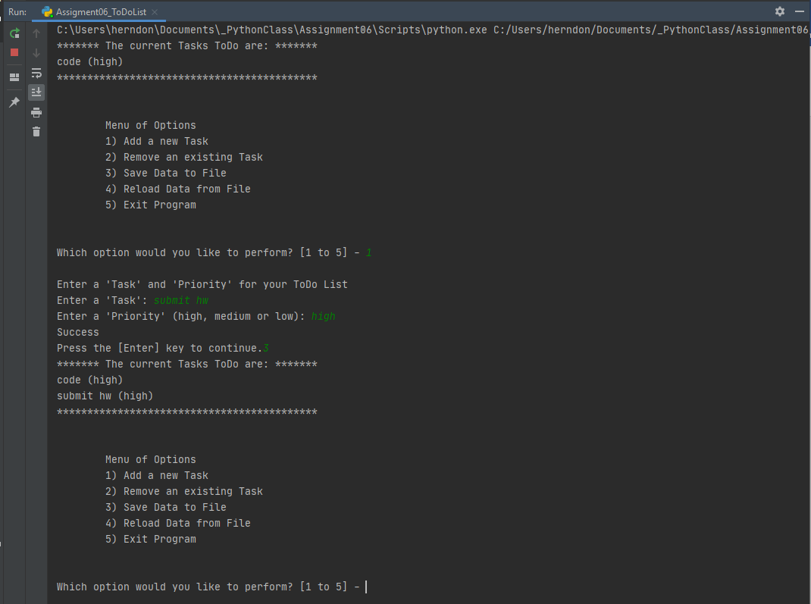

Figure 1: “ToDoList.py” running in PyCharm.

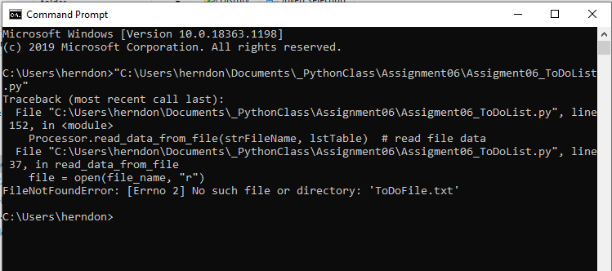

Figure 2: Error when trying to run “ToDoList.py” at the CMD prompt.

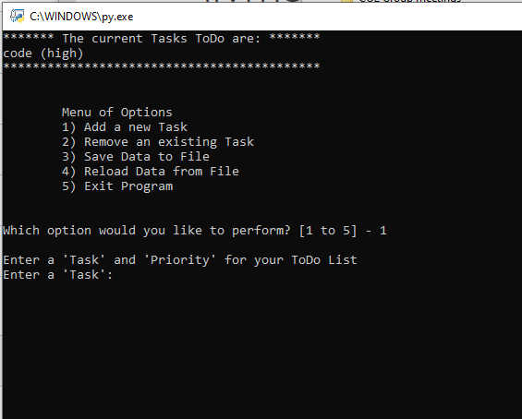

Figure 3: “ToDoList.py” running in Windows Shell.

Summary:

While the script is functional in PyCharm, it does not run in the CMD prompt. This appears to be a file path error that I was unable to resolve. The reason this script work at all is because significant assistance was provided by the Mr. Root through a starter video and answer .pdf. Clearly my acquired skills are not yet sufficient to tackle code of this complexity.

References and Resources:

Python.org, (2020). https://docs.python.org/3/library/functions.html

Intro to Programming (Python) Assignment 06. Undated.

https://canvas.uw.edu/courses/1417585/files/67261871?module_item_id=11076725Root, R.

Root, R. Mod6 Python Programing Notes (undated)

https://canvas.uw.edu/courses/1417585/files/67261870?module_item_id=11076723

Root, R. Mod0 Course Video. 11/04/2019.https://www.youtube.com/watch?v=jiXmXhwgHp8&feature=youtu.be

Assignment06_Starter.py

https://canvas.uw.edu/courses/1417585/files/67261875?module_item_id=11076726

Starting Assignment 06 Video

https://canvas.uw.edu/courses/1417585/pages/starting-assignment-06-video?module_item_id=11076727

Assignment06_Answer-1.pdf R.Root (undated)